Day 3 Lab Manual

# UNIVARIATE ANALYSIS IN R - MEASURES OF CENTRAL TENDENCY

## Exercise:

I. ARITHMETIC MEAN

a) Write suitable R code to compute the average of the following values.

12,7,3,4.2,18,2,54,-21,8,-5

SOURCE CODE:

v <- c(12,7,3,4.2,18,2,54,-21,8,-5);

print(mean(v))

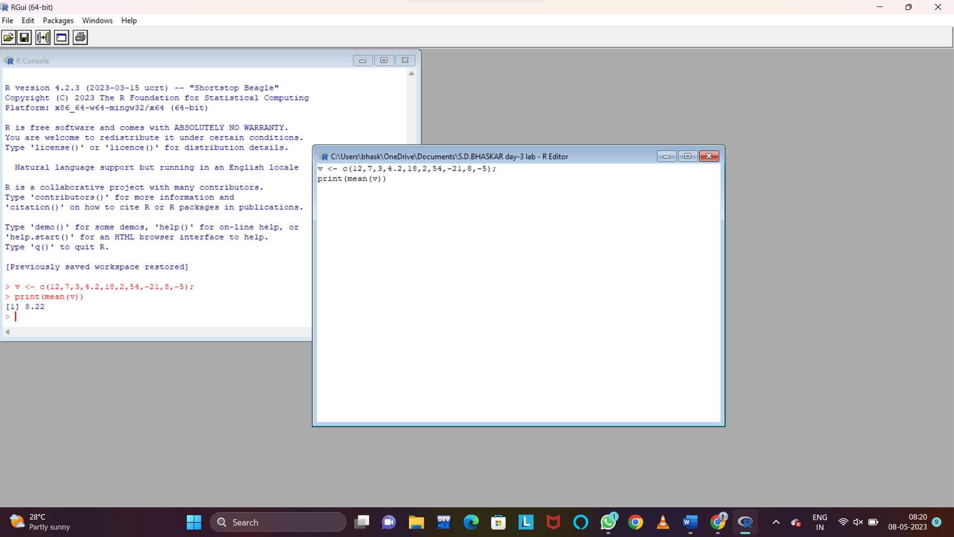

b) Compute the mean after applying the trim option and removing 3 values from each

end.

SOURCE CODE:

x <- c(12,7,3,4.2,18,2,54,-21,8,-5)

result <- mean(x,trim = 0.3)

print(result.mean)

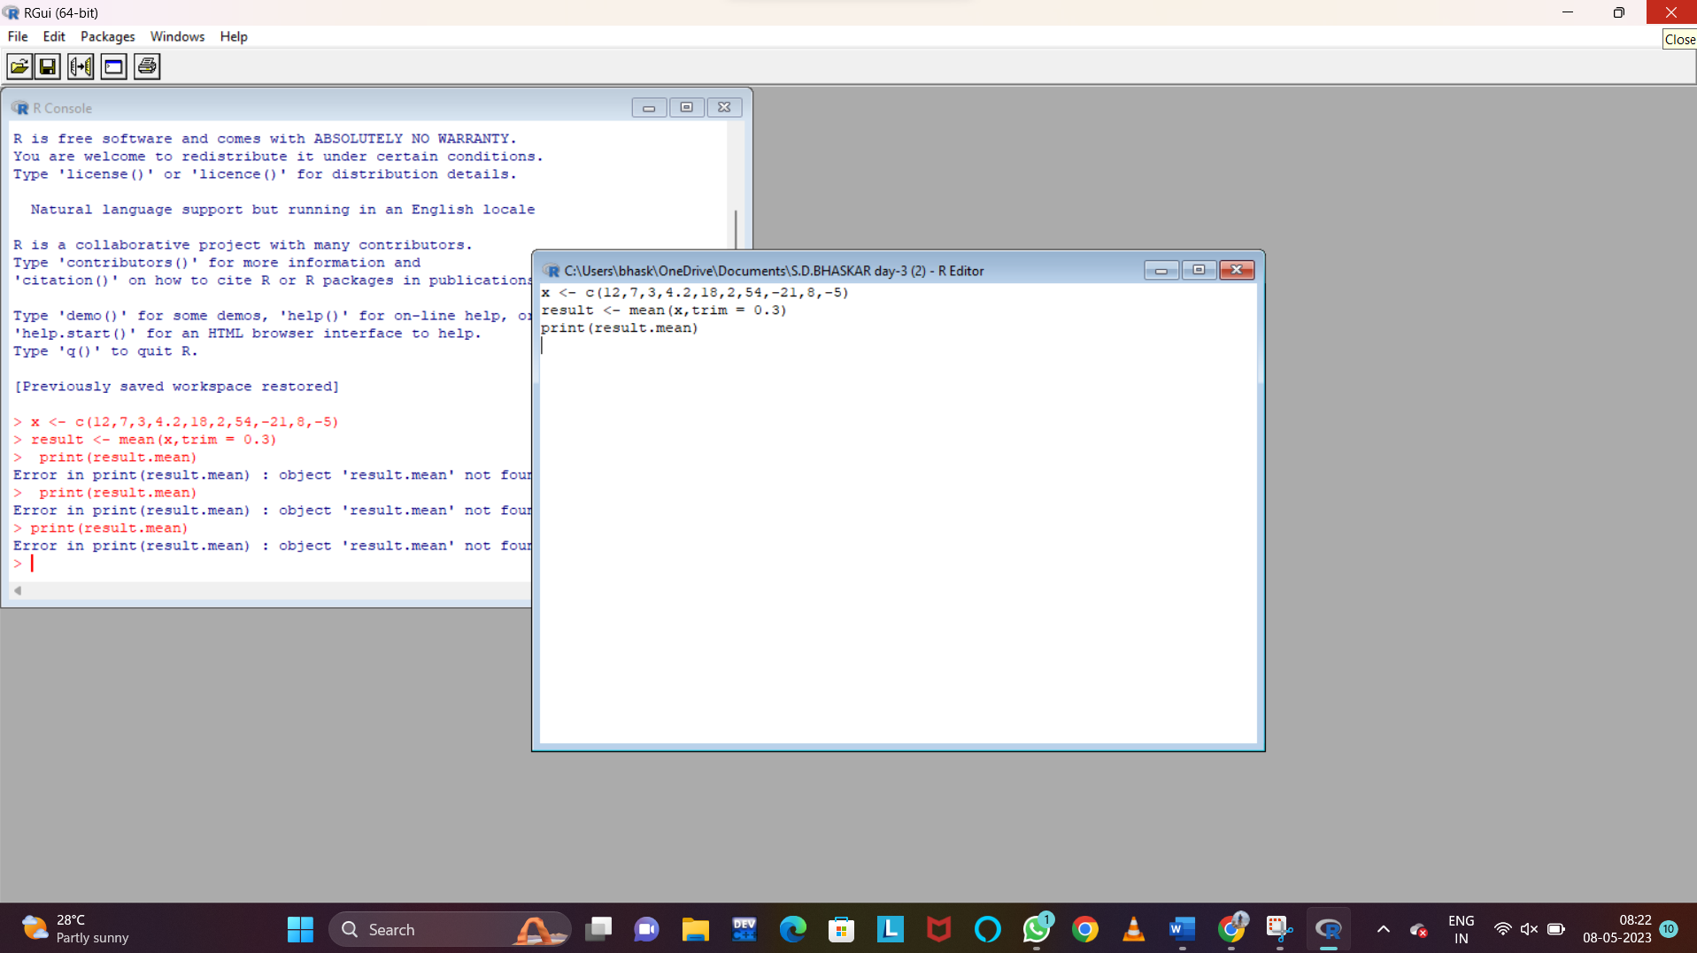

c) Compute the mean of the following vector .

(12,7,3,4.2,18,2,54,-21,8,-5,NA)

#If there are missing values, then the mean function returns NA.

# Find mean dropping NA values.

#To drop the missing values from the calculation use na.rm = TRUE

SOURCE CODE:

v <- c(v,NA)

print(mean(v))

print(mean(v,na.rm = TRUE))

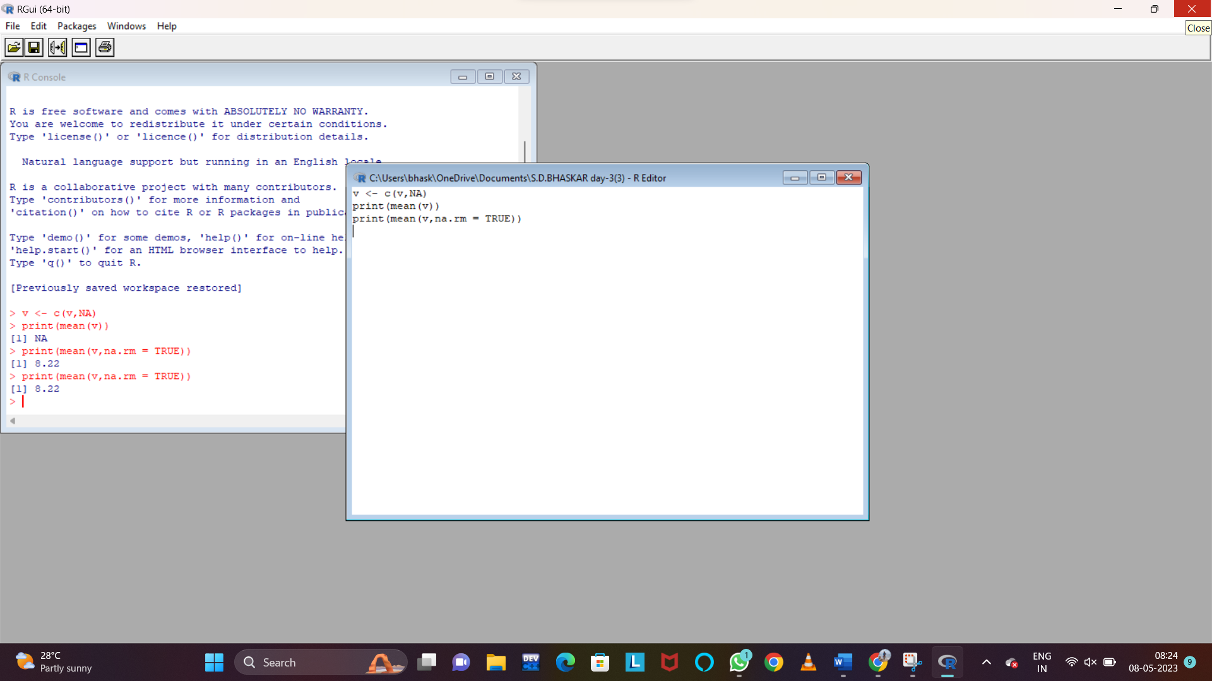

II.MEDIAN

Write suitable R code to compute the median of the following values.

12,7,3,4.2,18,2,54,-21,8,-5

SOURCE CODE:

v <- c(12,7,3,4.2,18,2,54,-21,8,-5);

x <- sort(v)

print(median(x))

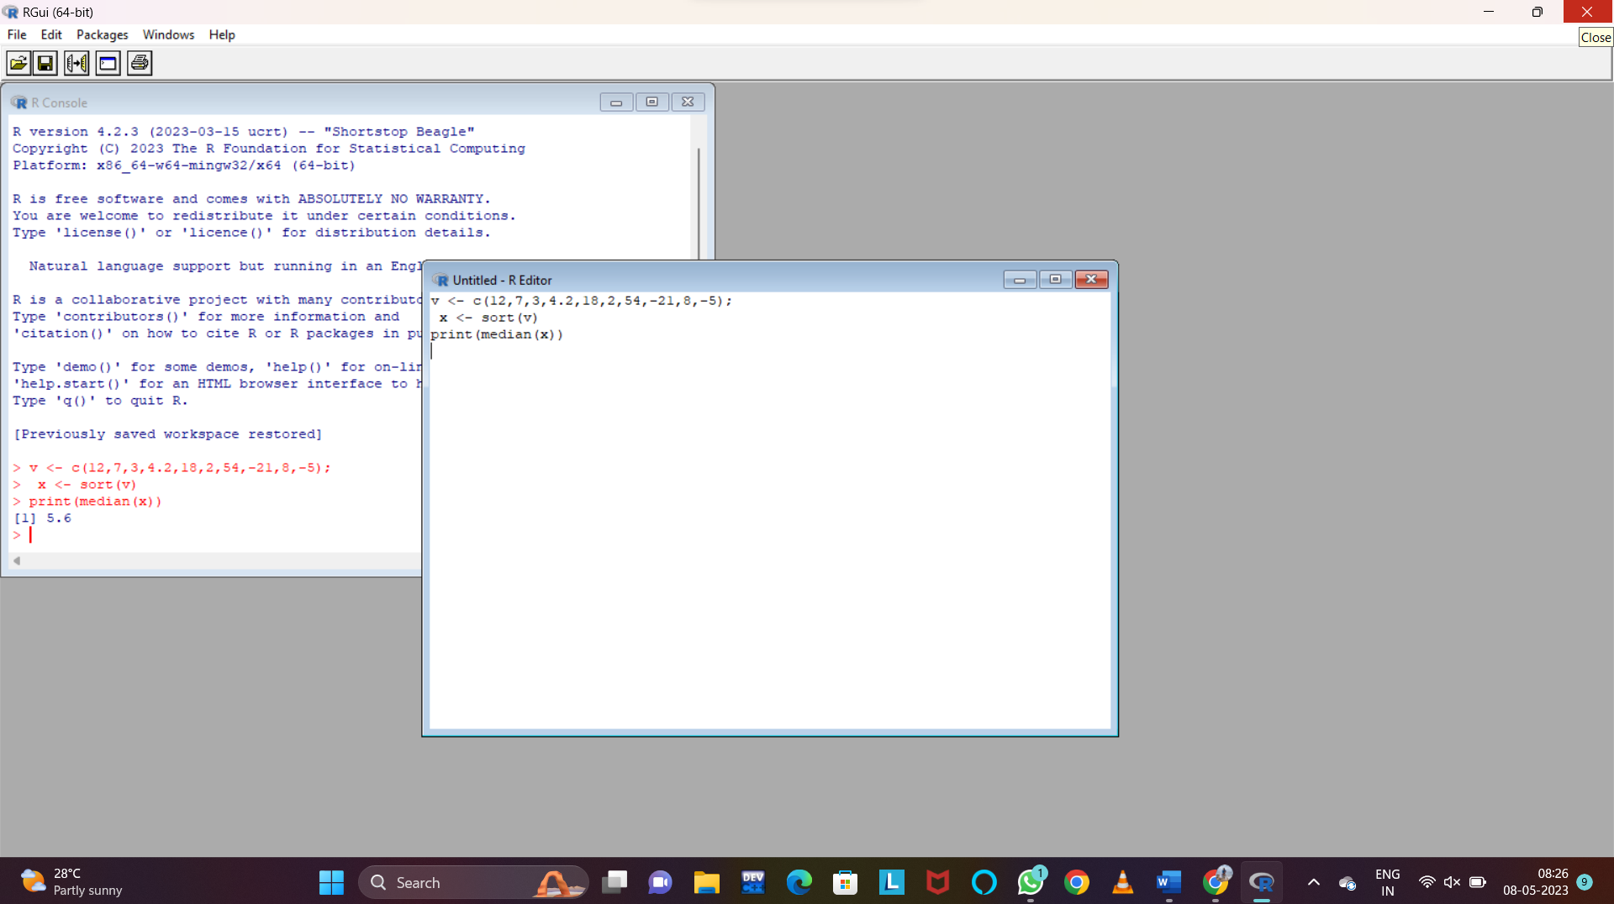

III. MODE

Calculate the mode for the following numeric as well as character data set in R.

(2,1,2,3,1,2,3,4,1,5,5,3,2,3) , (&quot;o&quot;,&quot;it&quot;,&quot;the&quot;,&quot;it&quot;,&quot;it&quot;)

UNIVARIATE ANALYSIS IN R - MEASURES OF DISPERSION

SOURCE CODE:

v <- c(2,1,2,3,1,2,3,4,1,5,5,3,2,3)

uni <- unique(v)

print(uni[which.max(tabulate(match(v, uni)))])

v1 <-c("o","it","the","it","it")

unistr <- unique(v1)

print(uni[which.max(tabulate(match(v1, unistr)))])

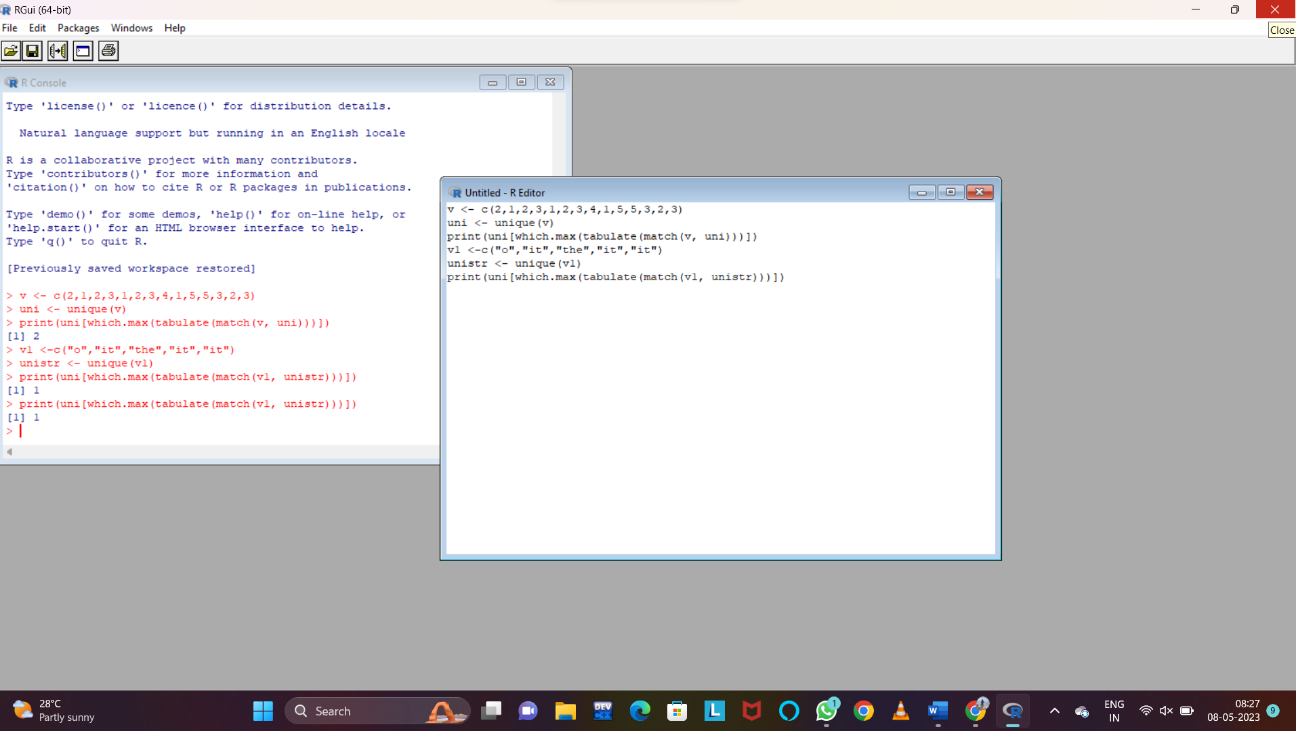

Exercise: 4

Download mpg dataset which contains Fuel economy data from 1999 and 2008 for 38

popular models of car from the URL given below.

https://vincentarelbundock.github.io/Rdatasets/datasets.html

Answer the following queries

i) Find the car which gives maximum city miles per gallon

A.

ii) Find the cars which gives minimum disp in compact and subcompact class

A.

Exercise: 5

Use the same dataset as used in Exercise 4 and perform the following queries

i) Find the standard deviation of city milles per gallon

A.

ii) Find the variance of highway milles per gallon

A.

Exercise 6

Use the same dataset and perform the following queries

i) Find the range of the disp in the data set mpg

A.

ii) Find the Quartile of the disp in the data set mpg

A.

iii) Find the IQR of the disp column in the data set mpg

A.

Exercise 7

#Install Library

library(e1071)

a. Find the skewness of city miles per mileage in the data set mpg ?

Use qplot function and display the graph for the city miles per mileage column

A.

b. Find the kurtosis of city miles per mileage in the data set mpg

A.